
UNDERGRADUATE CURRICULUM COMMITTEE (UCC)
PROPOSAL FORM

A.1. Course or program | Artificial IntelligEnce B.S.
Replacing
A. 1b. Academic unit | School of Business
A.2. Proposal type | Program: creation
A.3. Originator | Timothy Henry | Home department | CSIS (Computer Science and Information Systems)
A.4. Context and Rationale Must include additional information listed in smart tip for all new programs. If online course or program, you need to explain what mode(s) you plan to use and why you need that specific delivery. | The CSIS Dept would like to expand our offerings to include a Bachelor of Science major in Artificial Intelligence to meet the demands of our existing and potential students and employers in the IT industry. This new AI program uses a combination of existing computer science courses and seven new courses.  Artificial Intelligence (AI) and Machine Learning (ML) are rapidly transforming the world and are some of the most in-demand skills in the job market today. AI is being used in a wide range of industries, from healthcare to finance to defense to manufacturing, and is expected to create 133 million new jobs by 2030 (McKinsey). About 65% of companies are currently using AI internally, while 74% are testing it (Deloitte). Almost 25% of jobs are expected to be “disrupted” by AI over the next five years (World Economic Forum). Rhode Island College has a responsibility to prepare our graduates for this new workplace.  The CSIS Dept at Rhode Island College currently offers B.S. degrees in Computer Information Systems, Computer Science and Cybersecurity and a B.A. in Computer Science. It also offers minors in Cybersecurity, Data Analytics, and Web Development. Rhode Island College has the opportunity to become a leader in this field as no other peer university in the region offers a bachelor’s degree in Artificial Intelligence or Machine Learning. Based on a February, 2024, NSF report, only 170 schools nationwide offer any type of AI program (graduate major, undergraduate major, minor, or certificate). Only 2% of non-R1 schools offer any AI program and just 12 universities offer an undergraduate AI major.  As this field is rapidly evolving and maturing, there few standards for AI workforce roles. NIST is developing definitions. This major supports all five DCWF (Department of Defense Cyber Workforce) AI work roles. Academically, this major addresses all Knowledge Units in the current draft of the ACM AI Knowledge Area. This March 18 and 19, Drs. Mello-Stark and Henry participated in an NSF funded workshop to develop standards for the NSA CAE-AI (Center of Academic Excellence in AI) designation program.  The Rhode Island College Artificial Intelligence major will stand apart by preparing students to design, implement, and evaluate machine learning models while also providing the business and technical skills needed to integrate AI models into workflows. Given that Rhode Island College educates most of the college graduates who live and work in the state, and our graduates benefit from a well-rounded education, Rhode Island College is uniquely qualified to create and offer this new business-focused degree to serve the current and future needs of RI businesses.  A computer science and an artificial intelligence degree share a solid foundation in the fundamental concepts and principles of computing, including programming languages, data structures, and algorithms. While this foundation is essential for understanding the theoretical underpinnings of AI; it is not enough to prepare students to design, implement, and apply AI algorithms. Artificial intelligence models are complex structures that vary depending on purpose, such as computer vision, natural language processing, financial forecasting, autonomous vehicles and robotics. To prepare students to effectively contribute to the workforce, an effective AI program needs to address model structures and when and how to apply them.  While data analytics and data science provide students with the skills needed to collect, manipulate, analyze, and visualize data for decision-making, this is a small part of the process for building, training, testing, and validating an AI model. Each type of AI model has specific needs for feature engineering, removing bias, and providing fairness in the model. Once the data has been prepared and the machine learning model designed, the training process requires many tuning decisions to ensure the best model is created based on the data and business purpose.  This program has been designed with these goals in mind:  - Meeting AI workforce needs – determined from references listed above, meetings with industry and the NSA AI team.  - Providing a 100-level Pathways course that can also be taken by high school students. (CSCI 141)  - Hope Scholarship friendly –moderate number of credits for a B.S. degree (52) and a total of 4 electives  - A Writing in the Discipline course  - Facilitate Data Science, Math or Computer Science Minors for AI Majors  - Facilitate AI Minor for Data Science, Math or Computer Science Majors  - Possible double-majors in AI and either Computer Science or Data Science  - Provide courses that can be general electives for other programs  (CSCI 141 & CSCI 342W)  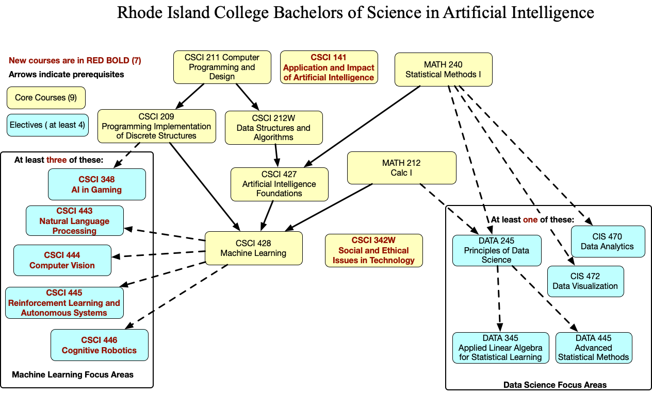
A.5. Student impact  Must include to explain why this change is being made? | This unique and important program has the potential to attract new students to the college and meet the increasing hiring demands of local and national employers.  This program packages existing computer science, data science and artificial intelligence courses in a way that supports these programs. Having artificial intelligence majors in these courses expands the learning opportunities for all our students.  The new artificial intelligence and machine learning courses created for the program can provide existing students with additional electives to enhance their technology skillsets.
A.6. Impact on other programs | Existing CIS, CSCI, and Cybersecurity majors may switch their major to the new Artificial Intelligence major or double major in both AI and CIS/CSCI/Cybersecurity.  The AI major requires MATH 212 and MATH 240 and has DATA 245 and DATA 345 and DATA 445 as electives; therefore, those courses may see an increase in enrollment.
A.7. Resource impact | Faculty PT & FT: | Existing CSCI faculty and/or adjunct faculty will teach the courses. Depending on the growth of the new AI Program, additional faculty and adjuncts may be needed.
 | Library: | None
 | Technology (for in person delivery) | None. Courses will use existing classrooms and/or computer labs.
 | Technology: (for online delivery. Must be RIC supported) | None
 | Facilities: | None. Courses will use existing classrooms and/or computer labs.
A.8. Semester effective | Fall 2024 | A.9. Rationale if sooner than next Fall |  | N/A
A.10. INSTRUCTIONS FOR CATALOG COPY: Use the Word copy versions of the catalog sections found on the UCC Forms and Information page. Cut and paste into a single file ALL the relevant pages from the college catalog that need to be changed. Use tracked changes feature to show how the catalog will be revised as you type in the revisions. If totally new copy, indicate where it should go in the catalog. If making related proposals a single catalog copy that includes all changes is preferred. Send catalog copy as a separate single Word file along with this form.
A.11. List here (with the relevant URLs), any RIC website pages that will need to be updated (to which your department does not have access) if this proposal is approved, with an explanation as to what needs to be revised:
Undergraduate Business Programs – add AI major to page
https://www.ric.edu/academics/undergraduate-programs/undergraduate-business-programs
Institute for Cybersecurity and Emerging Technologies – add link to AI major page.
https://www.ric.edu/academics/institute-cybersecurity-emerging-technologies

A. 12 Check to see if your proposal will impact any of our transfer agreements, and if it does explain in what way. Please indicate clearly what will need to be updated, including any changes in prefix numbers/titles for TES.
N/A
A. 13 Check the section that lists “Possible NECHE considerations” on the UCC Forms and Information page and if any apply, indicate what that might be here and contact Institutional Research for further guidance.

N/A

E. Program Proposals For IN-Person or mixed modalities (for fully online programs: see section F):

Complete only what is relevant to your proposal. Delete section E. if not needed. PLease add in the 2020 CIP number for MAJOR revisions or new programs in E 2; these can be found at https://nces.ed.gov/ipeds/cipcode/browse.aspx?y=56 consult with Institutional research to be sure you select the correct one.
 |  | New/revised
E.1. Enrollments  Must be completed. |  | 40
E. 2. 2020 CIP number |  | 11.0102
E.3. Admission requirements |  | N/A
E.4. Retention requirements |  | N/A
E.5. Course requirements for each program option. Show the course requirements for the whole program here. |  | Required Courses (28 credits)  - CSCI 141 Applications of Artificial Intelligence [4 cr] (NEW)  - CSCI 211 Computer Programming and Design [4 cr]  - CSCI 209 Programming Implementation of Discrete Structures [4 cr]  - CSCI 212W Data Structures [4 cr]  - CSCI 427 Artificial Intelligence Foundations [4 cr]  - CSCI 428 Machine Learning [4 cr]  - CSCI 342W Social and Ethical Issues in Technology [4 cr] (NEW)  Cognates (8 Credits)  - MATH 212 Calc I [4 cr]  - MATH 240 Statistical Methods I [4 cr]  Restricted Electives (16 credits)  At least one of Data Science Focus Areas:  - CIS 470 Data Analytics [4 cr]  - CIS 472 Data Visualization [4 cr]  - DATA 245 Principles of Data Science [4 cr]  - DATA 345 Applied Linear Algebra for Statistical Learning [4 cr]  - DATA 445 Advanced Statistical Methods [4 cr]  At least three of Machine Learning Focus Areas:  - CSCI 348 Artificial Intelligence in Gaming [4 cr] (NEW)  - CSCI 443 Natural Language Processing [4 cr] (NEW)  - CSCI 444 Computer Vision [4 cr] (NEW)  - CSCI 445 Reinforcement Learning and Autonomous Systems [4 cr] (NEW)  - CSCI 446 Cognitive Robotics [4 cr] (NEW)
E.6. Credit count for each program option |  | Required Courses (28 credits)  Cognates (8 Credits)  Restricted Electives (16 credits)  Total: (52 credits)
E.7. Note any needs for program accreditation (if relevant). |  | N/A
E.8 Program modality. Online percentage of delivery; calculate % within required hybrids and the total for the program cannot go over 49% |  | Mixed course types (20 - 25 % online)
E.9 Will any classes be offered at sites other than RIC campus or the RI Nursing Ed. Center?* |  | NO
E. 10. Do these revisions reflect more than 25% change to the program?* |  | NO
E.11. Program goals  Needed for all new programs |  | Upon the completion of this program, students will be able to:  - Create AI models that adapt to dynamic and evolving data, demonstrating adaptability and flexibility.  - Evaluate the performance of AI models, considering metrics like accuracy, precision, recall, and F1-score.  - Compare and contrast various AI techniques for specific applications, identifying their strengths and weaknesses.  - Develop innovative AI solutions for complex, multifaceted problems from subfields of AI, such as computer vision, natural language processing, and robotics.  - Critically assess the ethical, legal, and societal impacts of AI technology by examining issues like bias, fairness, and privacy to make well-informed recommendations and decisions.  - Assess the economic and business value of AI solutions, considering factors like cost-effectiveness, return on investment, and market feasibility.
E.12. Other changes if any |  | N/A
* If answered YES to either of these questions will need to inform Institutional Research and get their acknowledgement on the signature page.

G. Signatures
- Changes that affect General Education in any way MUST be approved by ALL Deans and COGE Chair.
- Changes that directly impact more than one department/program MUST have the signatures of all relevant department chairs, program directors, and their relevant dean (e.g. when creating/revising a program using courses from other departments/programs). Check UCC manual 4.2 for further guidelines on whether the signatures need to be approval or acknowledgement.
- Proposals that do not have appropriate approval signatures will not be considered.
- Type in name of person signing and their position/affiliation.
- Send electronic files of this proposal and accompanying catalog copy to curriculum@ric.edu to the current Chair of UCC. Check UCC website for due dates. Do NOT convert to a .pdf.

G.1. Approvals: required from programs/departments/deans who originate the proposal. THESE may include multiple departments, e.g., for joint/interdisciplinary proposals.
Name | Position/affiliation | Signature | Date
Suzanne Mello-Stark | Chair of Computer Science and Information Systems | *approved by email | 2/23/2024
Rebecca Sparks | Chair of Department of Mathematical Sciences | *approved by email | 2/23/2024
Quenby Hughes | Dean of Arts and Sciences | *approved by email | 2/23/2024
Marianne Raimondo | Dean of School of Business | *approved by email | 2/23/2024

G.2. Acknowledgements: REQUIRED from OTHER PROGRAMS/DEPARTMENTS (and their relevant deans if not already included above) that are IMPACTED BY THE PROPOSAL. SIGNATURE DOES NOT INDICATE APPROVAL, ONLY AWARENESS THAT THE PROPOSAL IS BEING SUBMITTED. CONCERNS SHOULD BE BROUGHT TO THE UCC COMMITTEE MEETING FOR DISCUSSION; all faculty are welcome to attend.
Name | Position/affiliation | Signature | Date

