
UNDERGRADUATE CURRICULUM COMMITTEE (UCC)
PROPOSAL FORM

Cover page scroll over blue text to see further important instructions: please read.
N.B. DO NOT USE HIGHLIGHT, please DELETE THE WORDS THAT DO NOT APPLY TO YOUR PROPOSAL
ALL numbers in section (A) need to be completed, including the impact ones.
A.1. Course or program | POL 269 International LGBTIQ+ Rights
A.2. Proposal type | Course: creation
A.3. Originator | Robyn Linde | Home department | Political Science
A.4. Context and Rationale | This course fills a gap in current program offerings by providing a comparative lens with which to view the development, challenges, and successes of the global gay rights movement. The meteoric rise of global LGBTIQ+ rights is both part of and distinct from prior civil rights movements. We seek in the course to understand this phenomenon, the complexities of sexuality and identity, and the ways in which political actors manifest their claims to equality, dignity, and happiness. This course will explore the rights of lesbian, gay, bisexual, transgender, intersex and queer individuals and their communities from an international and comparative perspective. Students will learn the history of the global gay rights movement, understand gender and sexual oppression, and evaluate modern efforts to utilize nongovernmental organizations (NGOs) and international governmental organizations (IGOs) to achieve equal rights. We will, above all, frequently and consistently evaluate the LGBTIQ+ agenda, claims to Western bias in its development, and efforts by civil society to lift up marginalized voices including those in the Global South.
A.5. Student impact | Exposure to cultural differences among LGBTIQ+ communities around the world, including an analysis of comparative approaches and understandings of justice, equality, and happiness.
A.6. Impact on other programs | none
A.7. Resource impact | Faculty PT & FT: | none
 | Library: | none
 | Technology | none
 | Facilities: | none
A.8. Semester effective | Fall 2023 | A.9. Rationale if sooner than next Fall

B. NEW OR REVISED COURSES DO NOT use highlight. Delete this whole page if the proposal does not include a new or revised course.

New
Examples are provided for guidance, delete the ones that do not apply
B.1. Course prefix and number | POL 269
B.3. Course title | International LGBTIQ+ Rights
B.4. Course description | Students will explore the rights of lesbian, gay, bisexual, transgender, intersex and queer individuals and their communities from an international and comparative perspective.
B.5. Prerequisite(s) | Completion of FYS, FYW and at least 45 credits
B.6. Offered | Fall (odd years)
B.7. Contact hours | 4
B.8. Credit hours | 4
B.10. Grading system | Letter grade
B.11. Instructional methods | Lecture , Small group
B.12. CATEGORIES  12. a. How to be used |  |  | | Free elective |
12 b. Is this an Honors  course? |  |  | | NO
12. c. General Education  N.B. Connections must include at  least 50% Standard Classroom  instruction. |  |  | YES |  category: Connections
12. d. Writing in the  Discipline (WID) |  |  | | NO
B.13. How will student performance be evaluated? | Attendance | Class participation | Presentations | Papers | Class Work | Quizzes | Projects |
B.14 Recommended class-size |  |  | 30
B.15. Redundancy statement
B.17. Course learning outcomes: List each one in a separate row |  | How will each outcome be measured?
Critical and Creative Thinking |  | Critical and creative thinking will be primarily accomplished through discussions, development and drafting of case studies, and comparative analysis. Students will contribute to shared knowledge by comparing two countries (or other sub-units) on a public policy issue area within LGBTIQ+ rights. There will be significant opportunity to learn about non-Western struggles within LGBTIQ+ communities and, by comparing these countries and communities, we will lay the groundwork for our discussions about justice, rights, and happiness.
Written Communication |  | Case studies are a central part of the course. As such, assignments pertaining to the case studies will be scaffolded, including practice with the comparative method, evaluating sources on LGBTIQ+ issues around the world, and finding links and connections among cases. A comparative summary linking the case studies will be assigned after students have practiced the comparative method, read comparative cases, and drafted their own case studies. For each stage of this process, there will be rough drafts, peer reviews, and professor feedback, and, over the course of the semester, students will improve their ability to write persuasively.
Research Fluency |  | Via individual research on a sub-topic of interest to them, students’ ability to conduct social scientific research and evaluate empirical sources will be improved by the end of the semester. This is especially important for research on global LGBTIQ+ communities because many of the issue areas facing LGBTIQ+ people are undertheorized and lack the traditional body of peer reviewed sources important in scholarly inquiry. As such, students will be asked to evaluate reports from nongovernmental organizations (NGOs) and local activists working in the regions. They will be presented with a central social scientific dilemma of “generalization,” or determining how applicable or relevant a study or report is to a particular issue, country, or community.
Oral Communication |  | There will be multiple opportunities for students to improve their oral communication skills including a final presentation at the end of the semester. Additionally, students will be asked to present their case studies upon completion around the middle of the semester. Feedback will be provided by the professor and by peers.
Collaborative Work |  | Much of classwork will be spent in problem-based learning groups where students will work collectively to identify problems, evaluate solutions, and challenge contemporary constructions of sexuality and rights. Additionally, students will work closely with peers on written case studies and presentations, improving their own skillsets by evaluating the strengths and weaknesses of the work of classmates.

B.18. Topical outline: Do NOT insert whole syllabus, we just need a two-tier outline
1. Beginnings
a. Introduction to LGBTIQ+ rights
b. The early (modern) movement 1914-1965
c. Queering global politics
2. Fighting back
a. The rise of gay rights 1965-1981
b. The AIDS crisis and international resistance 1981-2000
3. International order
a. Global equality efforts Since 2000
b. LGBTIQ+ in international organizations
4. Digging in
a. Transgender rights and gender diversity
b. Bisexuality and gender conformity
c. Intersectionality: race and sexuality
d. Queer Culture
5. Critical queer politics
a. Anti-capitalist critiques
b. The queer state: homonationalism, colonialism, and pinkwashing
6. Going forward
a. Liberation and vision

D. Signatures

D.1. Approvals: required from programs/departments/deans who originate the proposal. may include multiple departments, e.g., for joint/interdisciplinary prposals.
Name | Position/affiliation | Signature | Date
Michelle Brophy-Baermann | Chair of Political Science | 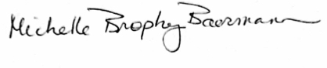 | 03/13/23
Earl Simson | Dean, FAS | Earl Simson | 3/15/23
Marianne Raimondo | Dean, School of Business | *Approved via e-mail | 4/10/2023
Justin DiLibero | Dean, School of Nursing | 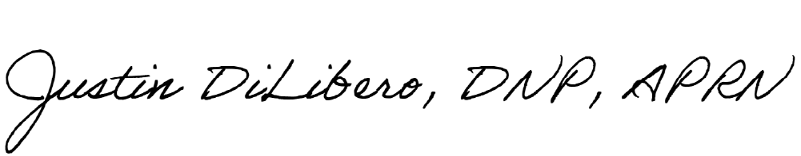 | 3/22/2023
Jayashree Nimmagadda | Dean, School of Social Work | *Approved via e-mail | 4/13/2023
Jeannine Dingus-Eason | Dean, Feinstein School of Education and Human Development | *Approved via e-mail | 3/20/2023
Joseph Zornado | Chair, Committee on General Education | *Approved via e-mail | 4/7/2023

