UNDERGRADUATE CURRICULUM COMMITTEE (UCC)
ACTION FORM

NOVEMBER 2023 ACTIONS

Report of Undergraduate Curriculum Committee Action
Document(s): #23-24-016

Recommendation: Approve.
Date of Action: 11/17/2023
Originated by: Carol Cummings Dept. Dean FSEHD
Recommended by Undergraduate Curriculum Committee
(Department, Person, or Group)
Effective date: Spring 2024.
Catalog citations: See pages on Curriculum website.

Comments: #016 asks to approve revisions to the admission requirements for the School of Education (excepting the Youth Development program) to remove certain unnecessary barriers. There will be a readjustment of the acceptable range for the GPA and the FYW 100 requirement will be lowered to a B- and other support accommodations instituted to also allow admission with a C (if enroll in the recently created CURR 242 Foundational English Language Arts course). These changes are more in line with what other peer institutions use so that applying to RIC does not place students at a disadvantage. To better serve current students (as this is a dual admission process) there is a request to have this proposal made effective for Spring 2024.

APPROVALS
Chair, Undergraduate Curriculum Committee: Susan Abbotson
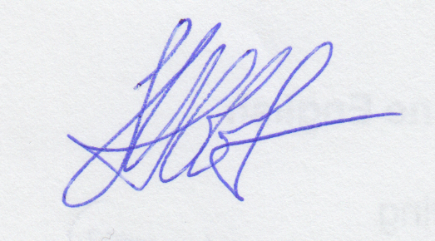
Date: 11/17/2023

Report of Undergraduate Curriculum Committee Action
Document(s): #23-24-017 to #23-24-019

Recommendation: Approve.
Date of Action: 11/17/2023
Originated by: Desirée Ciambrone Dept. Sociology
Recommended by Undergraduate Curriculum Committee
(Department, Person, or Group)
Effective date: Fall 2024.
Catalog citations: See pages on Curriculum website.

Comments: #017 asks to approve the creation of a new course: SOC 313 Sociology of Death and Dying for use in the Gerontology/Aging Studies and Sociology major and minor programs. This proposal includes the request to add the course to the Sociology major and minor, to two of the Health Sciences programs: Health Sciences and Human Services, to Health Care Administration under the former Gerontology category to also be renamed Aging Studies in line with the changes being made to the Gerontology minor/CUS titles below, and to the major and minor Community Programs and Health Promotion. No totals will be affected. #18 asks to approve the retitling of the Gerontology minor and CUS to become Aging Studies, and to revise both programs to include the new SOC 313 Sociology of Death and Dying course as an elective. Finally, #19 asks for a small revision to the prefix of GRTL 314 to become AGNG 314 to align with new program title and since this is cross listed with NURS 314 that also needs a slight revision to the description. Health Sciences, Heath Care Administration and Community and Public Health Promotion also use GRTL 314 as an elective so will be informed of the change.

APPROVALS
Chair, Undergraduate Curriculum Committee: Susan Abbotson
Date: 11/17/2023

The UCC was also asked to vote on an amendment to the committee’s Council By-Laws to update the membership guidelines to better reflect current programs and enrollment. Instead of having three members from FSEHD and one from the School of Business, from Fall 2024, we shall elect two from each. Further friendly amendments were made to require the Dean (or Associate Dean) of FAS to take one of the two Dean positions with the Provost appointing the second Dean (or Associate Dean) from a different school.
Thus far was unanimously approved 11/17/2023 by UCC. There was also discussion regarding the way the FAS seats were divided that the committee needs more information to resolve, so we shall fix that before forwarding the proposal to Council for final approval.

