UNDERGRADUATE CURRICULUM COMMITTEE (UCC)
ACTION FORM

FEBRUARY 2022:

Report of Undergraduate Curriculum Committee Action
Document(s): #21-22-017 through #21-22-023

Recommendation: Approve.
Date of Action: 2/18/2022
Originated by: Eric Hall Dept. Dir. Medical Imaging

Recommended by Undergraduate Curriculum Committee
(Department, Person, or Group)
Effective date: Fall 2022.
Catalog citations: See pages on Curriculum website.

Comments: #017 asks to approve a new Medical Imaging BS major program in Vascular Interventional Radiology (VIR). Similar to the current Certified RT Computed Tomography major, students applying will bring in 60 transfer credits in the form of a Radiologic Technology Certification. The credits for this certification will include several transferrable General Education courses and some of the required cognates for the RIC program, and so, although the VIR program total is 101, students will be able to complete this and their Gen Ed. Program within 120 credits. The program will include several new courses in Vascular Interventional Radiology that will be required. #18 asks to approve a 17 credit CUS in Vascular Interventional Radiology (VIR) which will be made up of the new courses being created in Vascular Interventional Radiology for that new major, but this will also allow other majors in other Medical Imaging fields to extend their capabilities with additional certification. #019 through #023 are the new courses: VIR 300 Principles of Vascular Interventional Radiography; VIR 301 Procedures I; VIR 302 Procedures II; VIR 303 Clinical Education I; and VIR 304 Clinical Education II, all for use in the VIR major and CUS programs.

APPROVALS
Chair, Undergraduate Curriculum Committee: Susan Abbotson

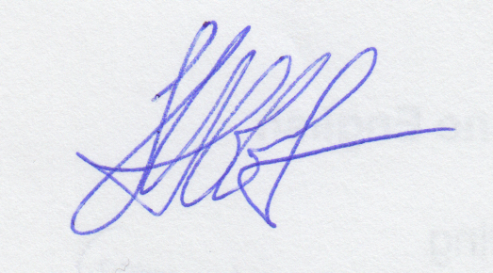

Date: 2/18/2022

Report of Undergraduate Curriculum Committee Action
Document(s): #21-22-024

Recommendation: Approve.
Date of Action: 2/18/2022
Originated by: Maureen Reddy Dept. English

Recommended by Undergraduate Curriculum Committee
(Department, Person, or Group)
Effective date: Fall 2022.
Catalog citations: See pages on Curriculum website.

Comments: #008 asks to approve a new single credit course, ENGL 203 Career Readiness for Humanities Majors, which can be taken as an elective by anyone, but is specifically geared toward the use of skills generated in majors in the Humanities. It will be offered annually and be graded S/U.

APPROVALS
Chair, Undergraduate Curriculum Committee: Susan Abbotson

Date: 2/18/2022

