2023-Report to the Undergraduate Curriculum Committee (UCC) on Transfer Minors
H. Shadoian
10-20-23

Background
The Transfer Minor policy was approved by UCC in 2019. It is a stackable credential based on specific associate degrees earned at CCRI or Bristol and is comprised of 18-24 credits required in the particular associate degree. RIC is the first in the country to offer a transfer minor. At the time of approval and initial implementation, I was the AVP for Enrollment Management, which included Undergraduate Admissions and I assigned the then transfer staff member to handle transfer minor posting (creating the process and doing the posting).

Below is the list of CCRI Transfer Minors (taken from RIC’s PLA webpage): https://www.ric.edu/academics/prior-learning-assessment/transfer-minors . I have recently suggested to Admissions that it would be useful to also link this webpage to the Admissions transfer webpage to potentially attract CCRI students who might request this on their own.

Below is the list of transfer minors
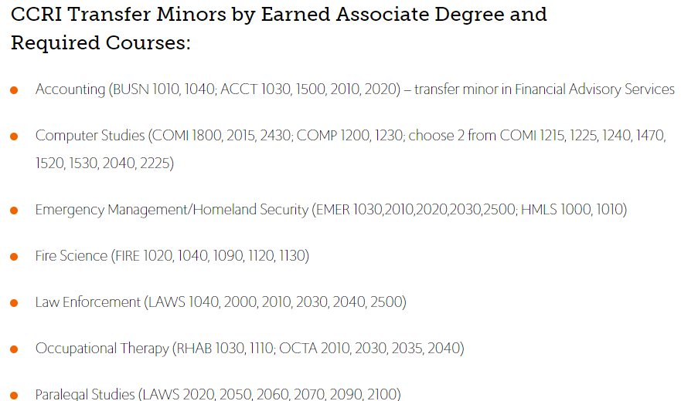

Note: We do not use the name of any existing RIC minor - so the transfer minor for the Associate degree in Accounting is called Financial Advisory Services.

RIC’s policy was highlighted in an Inside Higher Education blog in 2019: https://www.insidehighered.com/blogs/higher-ed-gamma/transfer-minors

Transfer "minors" are listed on the RIC transcript as part of the transfer credit posting list - not as a regular "earned" minor. It is printed under the transfer credit posting with "TMIN" as the course code and an assigned number indicating the specific transfer minor (ex. TMIN 203 is the transfer minor in Financial Advisory Services). It changes how the transfer credits are packaged for posting since most of the courses in the "minor" are electives (and appear as "XFER"). The single listing below for TMIN 203 replaces a list of multiple XFER Elective credits:
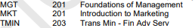

Initially, it was very easy to begin implementation. It was the responsibility of the former assistant director of transfer. In posting transfer credits of newly deposited CCRI students with earned associate degrees (from the list above), they “repackaged” a block of elective credits into a single transfer minor “course”.

Value to transfer student
The benefit to the student is two-fold:
1) having a "stackable credential" listed (conversation starter for job interviews, like the RIC English major who had a transfer minor in Fire Science)

2) Having a much shorter list of XFERs (elective credits) appearing on their transcript (a common complaint over the number of courses listed as elective or not able to articulate). It could also be a recruitment enticement (did you complete an associate degree in xxx? You are eligible to have a transfer minor posted on your RIC transcript).

I believe from the time of implementation to when the staff member left, they likely posted about 4-5 transfer minors. As mentioned in a previous report to UCC, the staff member removed all files on how to process transfer minors. The current associate director for transfer admission is still working on how the posting can be done again and students more easily identified.

Steps to identify eligible transfer students
We continue to struggle to produce a report for UCC on the number of transfer minors posted because we cannot access any data. We need to find a way. Otherwise, we may have to eliminate this policy, which I hope will not need to happen.

It is inefficient to run a query by admit term, select Last School code for CCRI, sort by credits earned (60 or more) and then pulling each individual transcript to see if an associate degree was earned and then look for the list of courses required in the transfer minor. It is far too manual a process. Currently, Admissions has nothing in PS that can capture if an incoming transfer applicant has an earned associates degree and in what area.

In the past year, I have done the following in an effort to identify eligible students.
- Contacted the transfer point person at CCRI to see if we could get a list of recent CCRI transfers with degree earned. She suggested we use the Clearinghouse.

- Reached out Sara Phillips in IR to ask if The Clearinghouse could provide us with a list of CCRI students at RIC with specific earned associate degree. Sara said RIC can’t make that request of non-RIC students and thinks maybe we could ask CCRI to run a list

- Will reach back to CCRI to ask if they could send us a spreadsheet of their May 2023 grads

- Jim Tweed said Admissions has implemented a new system using Slate and will see if there is any way they can create fields for type of degree earned. This could take some time since he is heavily involved in HOPE, but that he and Brian Stevens (associate director for transfer) are willing to look for ways to get this done.

- Brian Stevens will ask if CCRI could package the group of courses for transfer minors to identify them more easily.

While I considered putting in a ticket to MIS for a new query, it will not eliminate the need for someone to pull up individual transcripts. My thought is that this could happen at the time the admissions

I am hoping this could be done for new spring 2024 transfers.

